

**AVL240SDI**

**24” TFT LCD MONITOR**

**USER MANUAL**



**TABLE OF CONTENTS**

Table of contents 2

Warning 3

Precautions 3

About this user manual 5

Items included in package 5

1. IR Remote control 6
2. LCD Monitor Mounting Guide 9
3. Monitor controls 10
4. Connections 11
5. Monitor Settings via OSD Menu 11
   1. Picture 12
   2. Sound 12
   3. OSD Setup 13
   4. Advance 13
   5. PIP 14
   6. PC 14
   7. Geometry 15
   8. PC Timing 15
6. Special features 15
7. Technical specifications 16
8. Appendices 17

**WARNINGS:**

TO REDUCE THE RISK OF FIRE OR ELECTRIC SHOCK, DO NOT EXPOSE THIS PRODUCT TO RAIN OR MOISTURE.

DO NOT INSERT ANY METALLIC OBJECT THROUGH VENTILATION GRILLS.

**CAUTION:**

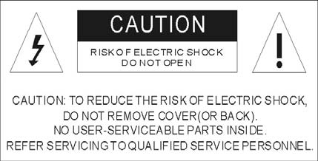

**EXPLANATION OF GRAPHICAL SYMBOLS**

|  |  |
| --- | --- |
|  | **Danger:** This symbol is intended to alert the user to the presence of un-insulated "dangerous voltage" within the product’s enclosure that may be of sufficient magnitude to constitute a risk of electric shock to a person. |
|  | Warning: This symbol is intended to alert the user to the presence of important operating and maintenance (servicing) instructions in the literature accompanying the appliance. |

**Precautions:**

**Safety**

Should any liquid or solid object fall into the cabinet, unplug the unit and have it check by qualified personnel before operating it any further.

Unplug the unit from the wall outlet if it is not going to be used for several days or more. To disconnect the cord, pull it out by the plug. Never pull the cord itself.

Allow adequate air circulation to prevent internal heat built-up. Do not place the unit on surfaces (rugs, blankets, etc.) or near materials (curtains, draperies) that may block the ventilations holes.

**Installation**

Do not install the unit in an extremely hot or humid place or in a place subject to excessive dust or mechanical vibration.

The unit is not designed to be waterproof. Exposure to rain or water may damage the unit.

**Cleaning**

Clean the unit with slightly damp soft cloth. Use a mild household detergent. Never use strong solvents such as thinner or benzene as they might damage the finish of the unit.

Retain the original carton and packing materials for safe transport of this unit in the future.

**Safety Precautions:**

**Federal Communications Commission (FCC) Statement**

This Equipment has been tested and found to comply with the limits for a Class B digital device, pursuant to Part 15 of the FCC rules. These limits are designed to provide reasonable protection against harmful interference in a residential installation. This equipment generates, uses and can radiate radio frequency energy and, if not installed and used in accordance with the instructions, may cause harmful interference to radio communications. However, there is no guarantee that interference will not occur in a particular installation. If this equipment does cause harmful interference to radio or television reception, which can be determined by turning the equipment off and on, the user is encouraged to try to correct the interference by one or more of the following measures:

* Reorient or relocate the receiving antenna.
* Increase the separation between the equipment and receiver.
* Connect the equipment into an outlet on a circuit different from that to which the receiver is connected.
* Consult the dealer or an experienced radio/TV technician for help.
* You are cautioned that changes or modifications not expressly approved by the party responsible for compliance could void your authority to operate the equipment.

|  |
| --- |
| This device complies with Part 15 FCC Rules. Operation is subject to the following two conditions:   1. This device may not cause harmful interference. 2. This device must accept any interference received including interference that may cause undesired operation. |

**About this User Manual**

This manual aims at assisting the user on how to operate the monitors described in this manual.

This manual is subject to rigid quality control. However, no guarantee can be given that mistakes are not present. We reserve the right to make changes to the manual without prior notice.

Before operating the appliance, please read this manual carefully and retain it for further reference. Verify that all appliance items are included in the delivery. Should items be missing, do not operate the appliance and contact your local dealer.

Never attempt to repair the appliance yourself. This should only be done by qualified service personnel.

Improper handling of the appliance will invalidate the warranty.

**Items included in package**

1x LCD Monitor

1x Power supply unit 12V DC

1x Power cord

1x VGA cable

1x Audio cable

1x IR remote control

1x User manual

1. **IR remote control**

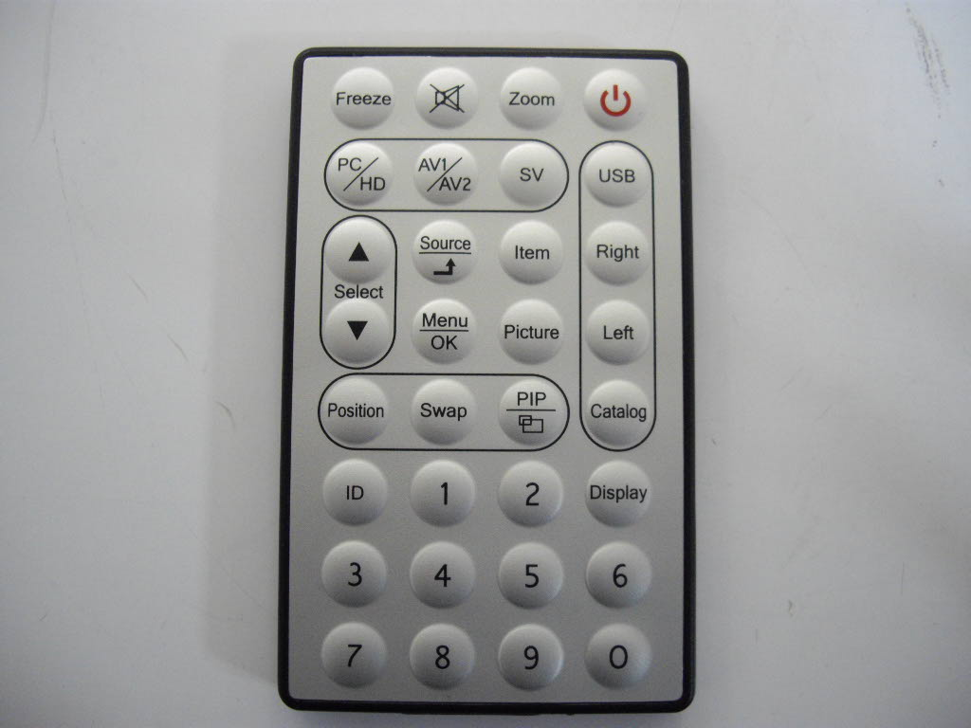

1. **Power**  
   Press this button to turn the monitor on/off.
2. **Zoom**  
   Press this button to toggle between the different picture formats: Full/Zoom/Subtitle/Regular/Panorama
3. **Mute**  
   Press this button to disable the sound. Press this button again to turn the sound on again.
4. **Freeze**  
   Press this button to freeze the picture. Press this button again to disable the freeze picture and to re-establish the normal picture.
5. **PC/HD, AV1/AV2, SV**You can select the appropriate signal source directly (PC = VGA).
6. **Item**Hot key for OSD adjustments of volume, contrast, brightness, hue, saturation, sharpness, and Red Green Blue.
7. **Source**To switch the video inputs (or sub picture source in pip mode), please use the IR remote control included in the delivery This button is also used as “Enter” and “Select” function in the OSD menu and to confirm your selected settings in the OSD menu.
8. **OK / Menu**Press this button to call-up the OSD menu. This button is also used as “Exit“. Note: The menu button is also used to return to the previous menu.
9. **Select ▲/▼**Directional buttons up/down.
10. **Display**  
    Press this button to call-up screen information such as resolution, signal source, etc.
11. **Picture**  
    Press this button to toggle between the different picture modes: **User, Standard, Movie, Vivid**.
12. **PIP**  
    Press this button to select the picture-in-picture function. Define the size of the sub picture: **Small, Medium, Large, POP Full, POP 4:3, OFF**.
13. **Swap**  
    When in PIP mode, press the swap button to switch the main picture and the sub picture. The swap button is only active if you have defined a sub-picture before.

1. **Position**  
   When in PIP mode, press the position button to define the position of the sub-picture: Either in one of the four screen corners or centered.
2. **ID**  
   Can be control several monitors are installed in the same area.  
   In ID mode, press ID key, then input setting number (01-99), to unlock “ID” function.
3. **0-9**  
   For ID setting number used.
4. **USB/Right/Left/Catalog:**

|  |  |
| --- | --- |
| (17.1) Press “USB” Key into the JPEG Menu. | (17.2) Press “MENU” Key into the USB Main menu |
| IMGP6603 | IMGP6598.JPG |
| (17.3) Press “Left” or “Right” key to select the JPEG/MP3/DRIVE function. | |
| IMGP6613 | IMGP6611 |
| (17.4) Press “Up/Down” Key to select play file. | |
| IMGP6599 | mp3 |
| (17.5) Press “Right” Key to see file listing | |
| IMGP6602 | IMGP6605 |
| (17.6) Press “Up/Down” Key to select the play file and press Right key to play.  Press “Menu” to stop play. Then press “Catalog” return the menu.  Press “Menu” into the USB Main menu. | |
| IMGP6601 | mp3 file |
| (17.7) Press “PC/HD”, “AV1/AV2” or “SV” to exit the USB function. | |
|  | |

1. **LCD Monitor Mounting Guide**
2. **Desktop**

Adjust the viewing angle of LCD to fit most comfortable monitoring status.

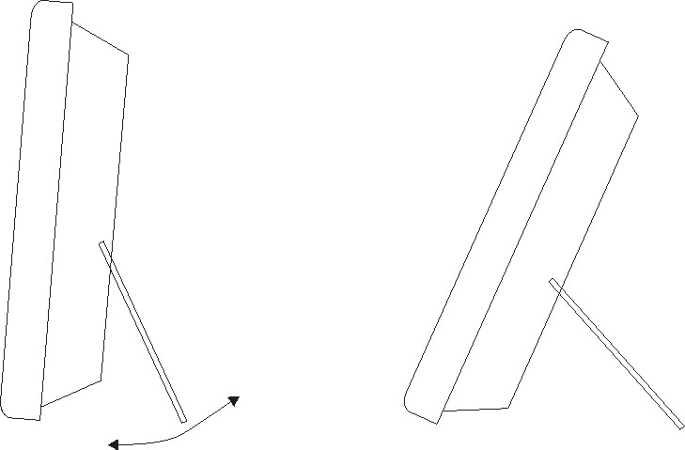

1. **Wall mount**

Free your space with wall mount design.

Please follow the fix-hole size in back panel to install the LCD to the wall.



**C. VESA Bracket**



1. **Monitor controls**



1. **Power**Turn the monitor on/off. LED: Green Monitor on LED: Red: Standby mode (no input signal)

**(2./3.) Adjust Up / Down** ▲/▼  
Increase or decrease the values in the OSD menu: Up: Increase the values. Down: Decrease the values.

**(4) Item/Select**Hot key for OSD adjustments of volume, contrast, brightness, hue, saturation, sharpness, and Red, Green, Blue.

**(5) Menu/Function**Press this button to call-up the OSD menu. This button is also used as “Exit“.

**(6) Source**To switch the video inputs, (or sub picture source in pip mode) This button is also used as “Enter” and “Select” function in the OSD menu and to confirm your selected settings in the OSD menu.

**KEY Lock Function:**

**Into key lock mode:  
Push “Menu” and “Item” after the LED flashes, OSD of screen will show “Key Lock”.**

**Into key unlock mode:**

**Push again after the LED flashes, OSD of screen will show “Key Unlock”.**

1. **Connections**



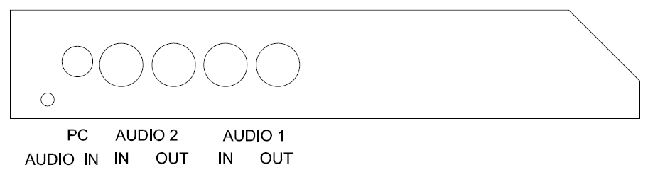

**NOTE:**

Connections of Audio

|  |  |  |  |
| --- | --- | --- | --- |
|  | **Audio 1** | **Audio 2** | **PC Audio** |
| **AV1** | X |  |  |
| **AV2** |  | X |  |
| **S-Video** |  | X |  |
| **PC** |  |  | X |
| **DVI** |  |  | X |

**SLM-2610N,SLM-3200N,SLM-4200N**

1. **Monitor Setting via OSD Menu**

Various monitor settings can be made using the OSD menu (On Screen Display). Press the Menu/OK button to call-up the OSD main menu. Here you can make adjustments to the following items:

* Picture
* Sound
* OSD Setup
* Advance
* PIP
* PC (at PC input signal)  
  Geometry (at PC input signal)

Use the **▲/▼** buttons to toggle between the different items.

Press the Source button to select the appropriate item.

* 1. **Picture**

Use the ▲▼ buttons to select adjusts item, and press source button to confirm. Then use the ▲▼ buttons to increase/decrease the values, or use “source” button to change the values. Press the menu button to return to the previous menu item.

|  |  |
| --- | --- |
| **Item** | **Description** |
| Contrast | Use the ▲▼ buttons to increase/decrease the screen contrast. |
| Brightness | Use the ▲▼ buttons to increase/decrease the screen brightness. |
| Hue | Use the ▲▼ buttons to increase/decrease the hue. |
| Saturation | Use the ▲▼ buttons to increase/decrease the saturation. |
| Sharpness | Use the ▲▼ buttons to increase/decrease the sharpness. |
| Color Temp. | Use the source buttons to select the color temperature: Normal, Warm, Cool, User. |
| DNR  (Noise Reduction) | Use the source buttons to select the level of noise reduction: Off, Low, Medium, High. |
| DLC | Use the source buttons to change the Black Level Extension on/off. |

* 1. **Sound**

Use the ▲▼ buttons to select adjusts item, and press source button to confirm. Then use the ▲▼ buttons to increase/decrease the values, or use “source” button to change the values. Press the menu button to return to the previous menu item.

|  |  |
| --- | --- |
| **Item** | **Description** |
| Volume | Use the ▲▼ buttons to adjust the volume. |
| Mute | Use the source buttons to change the Mute on/off. |
| Sound Mode | Use the source buttons to adjust the effect: User, Standard, Movie, Vivid. |
| Bass | Use the ▲▼ buttons to adjust the bass.(for R/L Audio in use) |
| Treble | Use the ▲▼ buttons to adjust the treble. (for R/L Audio in use) |
| Balance | Use the ▲▼ buttons to adjust the balance. (for R/L Audio in use) |

* 1. **OSD Setup**

Use the ▲▼ buttons to select adjusts item, and press source button to confirm. Then use the ▲▼ buttons to increase/decrease the values, or use “source” button to change the values. Press the menu button to return to the previous menu item.

|  |  |
| --- | --- |
| **Item** | **Description** |
| Language | Use the source buttons to select the language. |
| Set ID | Can be control several monitors are installed in the same area. Use the source buttons to into the function. Then use up/down key to select you setting the number (01~99), then press menu to exit.osd. Press IR remote control “ID” key again to confirm the SET ID function. |
| Gamma | Use the source buttons to set the gamma values.(0,1,2) |
| Freeze | Use the source buttons to freeze the picture. Press this button again to disable the freeze picture and to re-establish the normal picture. |
| OSD Time | Use the ▲▼ buttons to setting the OSD menu display time. |
| OSD Halftone | Use the ▲▼ buttons to setting the OSD menu display time. |
| Recall | Press the source button to restore the factory settings. |
| Obiter (Anti blur) | Use the source buttons to on/off the screen saver. (Screen protector: Anti blur) |
| Version | Firmware Version |

* 1. **Advance**

Use the ▲▼ buttons to select adjusts item, and press source button to confirm. Then use the ▲▼ buttons to increase/decrease the values, or use “source” button to change the values. Press the menu button to return to the previous menu item.

|  |  |
| --- | --- |
| **Item** | **Description** |
| Scale | Use the source buttons to select the picture size: Full/Zoom/Subtitle/Regular/ /Panorama. |
| Scan Size | Use the source buttons to select the real image size: Normal/Native |
| H Position | Use the ▲▼ buttons to position the picture horizontally. |
| V Position | Use the ▲▼ buttons to position the picture vertically. |

* 1. **PIP**

Use the ▲▼ buttons to select adjusts item, and press source button to confirm. Then use the ▲▼ buttons to increase/decrease the values, or use “source” button to change the values. Press the menu button to return to the previous menu item.

|  |  |
| --- | --- |
| **Item** | **Description** |
| Multi Window | Use source button to select the picture-in-picture function: PIP, POP Full, POP 4:3 Off. |
| Sub Source | Use source button to select the source of the PIP sub-picture. |
| Size | Use source button to set the size of the sub-picture: Small, Medium, Large. |
| Position | Use source button to define the position of the sub-picture. Note: This function is only active if you have previously defined a sub picture. |
| Border Color | Use source button to select the sub-picture background color: Black /Blue. |
| Sound Source | Use source button to select the sound source: Main/Sub. |
| Swap | Use source button to swap the main picture and the sub picture. Note: This function is only active if you have previously defined a sub picture. |

* 1. **PC**

Use the ▲▼ buttons to select adjusts item, and press source button to confirm. Then use the ▲▼ buttons to increase/decrease the values, or use “source” button to change the values. Press the menu button to return to the previous menu item.

|  |  |
| --- | --- |
| **Item** | **Description** |
| Contrast | Use the ▲▼ buttons to increase/decrease the screen contrast. |
| Brightness | Use the ▲▼ buttons to increase/decrease the screen brightness. |
| Color Temp | Use the source buttons to select the color temperature: Normal, Warm, Cool, sRGB, User. |
| Scale | Use the source buttons to select the picture size: Normal/Center |
| Auto Adjust | Use the source buttons to Adjust the best image. |

* 1. **Geometry**

Use the ▲▼ buttons to select adjusts item, and press source button to confirm. Then use the ▲▼ buttons to increase/decrease the values, or use “source” button to change the values. Press the menu button to return to the previous menu item.

|  |  |
| --- | --- |
| **Item** | **Description** |
| H Position | Use the ▲▼ buttons to position the picture horizontally. |
| V Position | Use the ▲▼ buttons to position the picture vertically. |
| Clock | Use the ▲▼ buttons to Adjust image distortion appearing as vertical or “noise” on the screen. |
| Phase | Use the ▲▼ buttons to Adjust image distortion appearing as horizontal or “noise” on the screen. |

* 1. **PC Timing**

|  |  |
| --- | --- |
| **Mode** | **Resolution** |
| 1 | 800 x 600 @ 60 |
| 2 | 800 x 600 @ 72 |
| 3 | 800 x 600 @ 75 |
| 4 | 1024 x 768 @ 60 |
| 5 | 1280 x 1024 @ 60 |
| 6 | 1360 x 768 @ 60 |
| 7 | 1440 x 900 @ 60 |
| 8 | 1920 x 1080 @ 60 |

1. **Special Features**

* Special Video Processor.
* 3G-SDI IN/OUT
* PIP Control Function (Only PC/Video).[Video/Video option]
* Screen protector (Anti-blur /Image auto move).
* NTSC/PAL Auto Switch.
* 3D De-interlace Technology.
* 3D Comb Filter Technology.
* Automatic Color Control and Color Killer.
* Luminance transient improvement(LTI),Chrominance transient improvement(CTI)
* Directional zoom engine.
* Video out support auto termination (75 Ohms).
* Build-in 2W speaker,
* Support IR remote controller.
* VESA standard bracket 75/100mm

1. **Technical specifications**

|  |  |
| --- | --- |
| **Monitor model** | **AVL240SDI** |
| System | PAL / NTSC |
| LCD panel | 24“ |
| Visible area (mm) | 531.3 x 298.8 |
| Picture format | 16:9 |
| Max. resolution | 1920x1080 |
| Pixel dot pitch (mm) | 0.276.7 x0.276 .7 |
| Colors | 16.7M |
| Brightness | 250 cd/m² [LED] |
| Contrast | 1000:1 |
| Response time(Tr/Tf) | 3.5/1.5 ms |
| View angle (U/D/L/R) | 80/80/85/85 |
| Video input/output | 2x / 2x Composite (BNC) ; 1x /1x SDI |
| S-Video input | 1x 4 Pin Mini Dim |
| Full HD input | 1x Full HD (A Type) |
| Audio input/output | 2x / 2x (RCA) |
| PC input | 1x VGA input (D-Sub 15 pin)  1x Audio input  1x DVI-D input |
| Speaker | 1x built-in speaker (2 watt) |
| SDI standards | 3G-SDI[SMPTE 424M]  HD-SDI[SMPTM 292M]  SD-SDI[SMPTE 259M] |
| SDI Video support | [3G] 1080P50/60(4:2:2)  [HD]720P@50/60Hz,1080i@50/60Hz  1080p25/30Hz  [SD]NTSC/60Hz,PAL/50Hz |
| SDI Video bandwidth | 2.97Gpbs&2.975/1.001Gpbs |
| SDI Cable Transmission | 3G-SDI[100Meter],HD-SDI[200Meter],SD-SDI[300Meter]  _(5C2V orRG6Cable) |
| 3D Comb Filter | Yes |
| 3D De-Interlace function | Yes |
| Picture-in-Picture (PIP) | Yes (video/PC) |
| OSD setting | Yes |
| Power input | AC 100-240V 50/60Hz, Adapter DC 12V/5A |
| Power consumption | Approx. 24watt |
| Dimensions (WxHxD) mm | 575.9 x 347.8 x 74.1 |
| Weight | 5.7kg |
| Operating temperature | 0° to 40° C |

Subject to technical changes without prior notice. Error expected.

**APPENDICES**

**TROUBLESHOOTING**

The tables provided below include some problems that the user may encounter while using the display and the corresponding solutions. Please refer to the contents of this section prior to contacting service personnel.

|  |  |  |
| --- | --- | --- |
| **Problem** | **Possible Causes** | **Solutions** |
| No picture | 1. Is the power cable connected to the unit?  2. Is the unit turned on?  3. Is the signal cable connected to the unit?  4. Is the unit in power saving mode? | 1. Make sure the power cable has been properly connected to the unit.  2. Turn on the unit.  3. Make sure the signal cable has been properly connected to the unit.  4. Press any key on computer keyboard. |
| Strange color | 1. Is the signal cable connected to the unit? | 1. Make sure the signal cable has been properly connected to the unit. |
| Picture distortion | 1. Is the signal cable connected to the unit?  2. Is the video input signal within the unit's specified frequency range? | 1. Make sure the signal cable has been properly connected to the unit.  2. Make sure the input signal is within the unit's specified frequency range. |
| Picture is too dim | 1. Have the unit's brightness and contrast settings been set to the lowest level? | 1. Adjust brightness and contrast |
| Only sound but no picture | 1. Is the connection of the input signal correct? | 1. Check connection of input signal.  2. Make sure the signal cable has been properly connected. |
| Only picture but no sound | 1. Is the signal cable connected to the unit?  2. Has the volume been set to the min level?  3. Is the audio cable connected to the unit? | 1. Make sure the signal cable has been properly connected to the unit.  2. Adjust the volume to an appropriate setting.  3. Make sure the audio cable has been properly connected to the unit. |

Please contact the customer service center of your local dealer if you have any questions regarding the unit after reading the information provided above.

**THANK YOU FOR CHOOSING AVUE PRODUCTS. ☺**