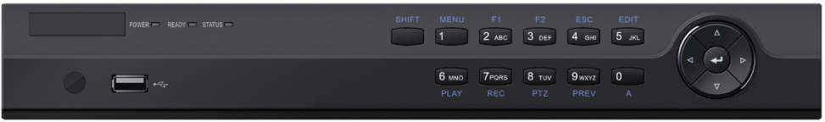
NR32P Series NVR
Professional and Reliable
- Dual-OS design to ensure high reliability of system running
- ANR technology to enhance the storage reliability when the network is disconnected
HD Input
- H.265/H.264/H.264+/MPEG4 video formats (MPEG4 is only for NR32P8-8 and NR32P6-16)
- Connectable to the third-party network cameras
- Up to 16 IP cameras can be connected
- Recording at up to 8 MP resolution
- Supports live view, storage, and playback of the connected camera at up to 8 MP resolution
HD Output
- HDMI and VGA independent outputs provided
- HDMI Video output at up to 4K (3840 × 2160) resolution
HD Storage
- Up to 2 SATA interfaces connectable for recording and backup
- Storage space effectively saved by 50% to 70% with the use of H.264+ decoding format
HD Transmission
- 1 self-adaptive 10M/100Mbps network interface for NR32P4-4
- 1 self-adaptive 10M/100M/1000 Mbps network interface for NR32P8-8 and NR32P6-16
- 4/8/16 independent PoE network interfaces are provided
Various Applications
- Centralized management of IP cameras, including configuration, information import/export, real-time information display, two-way audio, upgrade, etc.
- Connectable to smart IP cameras from AVUE and the recording, playing back, and backing up of VCA alarms can be realized
- VCA detection alarm is supported
- Instant playback for assigned channel during multi-channel display mode
- Smart search for the selected area in the video; and smart playback to improve the playback efficiency
- Supports HDD quota and group modes; different capacity can be assigned to different channels.
Features and Functions

Model |  | NR32P4-4 | NR32P8-8 | NR32P6-16
Video/  Audio input | IP video input | 4-ch | 8-ch | 16-ch
 | Incoming bandwidth | 40Mbps | 80 Mbps | 160 Mbps
 | Outgoing bandwidth | 80Mbps | 160 Mbps
Video/  Audio output | HDMI output  resolution | 4K (3840 × 2160)/30Hz, 1920 × 1080/60Hz, 1600 × 1200/60Hz, 1280 × 1024/60Hz, 1280 × 720/60Hz, 1024 × 768/60Hz | 4K (3840 × 2160)/30Hz, 2K (2560 × 1440)/60Hz, 1920 × 1080/60Hz, 1600 × 1200/60Hz, 1280 × 1024/60Hz, 1280 × 720/60Hz, 1024 × 768/60Hz
 | VGA output  resolution | 1920 × 1080/60Hz, 1280 × 1024/60Hz, 1280 × 720/60Hz, 1024 × 768/60Hz
 | Audio output | 1-ch, RCA (Linear, 1 KΩ)
Decoding | Decoding format | H.265/H.264/H.264+ | H.265/H.264/H.264+/MPEG4
 | Recording resolution | 8MP/6MP/5MP/4MP/3MP/1080p/UXGA/720p/VGA/4CIF/DCIF/2CIF/CIF/QCIF
 | Synchronous playback | 4-ch | 8-ch | 16-ch
 | Capability | 4-ch@1080p | 2-ch @ 4K, or 8-ch @ 1080p
Network management | Network protocols | TCP/IP, DHCP, Cloud P2P, DNS, DDNS, NTP, SADP, SMTP, NFS, iSCSI, UPnP™, HTTPS
Hard disk | SATA | 1 SATA interface for 1HDD | 2 SATA interfaces for 2HDDs
 | Capacity | Up to 6TB capacity for each disk
External interface | Two-way audio | 1-ch, RCA (2.0 Vp-p, 1kΩ)
 | Network interface | 1 RJ-45 100 Mbps full-duplex Ethernet interface | 1 RJ-45 10/100/1000 Mbps self-adaptive Ethernet interface
 | USB interface | Front panel: 1 × USB 2.0; Rear panel: 1 × USB 2.0 | Front panel: 1 × USB 2.0; Rear panel: 1 × USB 3.0
 | Alarm in/out | NA | 4/1
POE Interface | Interface | 4 RJ-45 100 Mbps full-duplex Ethernet interfaces | 8 RJ-45 10/100 Mbps self-adaptive Ethernet interfaces | 16 RJ-45 10/100 Mbps self-adaptive Ethernet interfaces
 | Power | ≤ 40 W | ≤ 120 W | ≤ 200 W
 | Supported standard | IEEE 802.3 af/at
General | Power supply | 48 VDC | 100 to 240 VAC
 | Power | ≤ 180 W | ≤ 180 W | ≤ 280 W
 | Consumption  (without hard disk) | ≤ 10 W | ≤ 15 W
 | Working temperature | -10 to +55° C (14 to 131° F)
 | Working humidity | 10 to 90 %
 | Chassis | 1U chassis | 385 mm chassis
 | Dimensions  (W × D × H) | 315 × 240 × 48 mm (12.4" × 9.4" × 1.9") | 385 × 315× 52 mm (15.2" × 12.4" × 2.0")
 | Weight  (without hard disk) | ≤ 1 kg (2.2 lb) | ≤ 3 kg (6.6 lb)
Specifications

Physical Interfaces
Index | Description | Index | Description
1 | AUDIO IN | 7 | USB 3.0 Interface.
2 | AUDIO OUT | 8 | GND
3 | VGA Interface | 9 | 100 to 240 VAC power supply
4 | HDMI Interface | 10 | Power Switch
5 | Controller Port, Alarm In/Alarm Out | 11 | Network Interfaces with PoE function
6 | LAN Network Interface
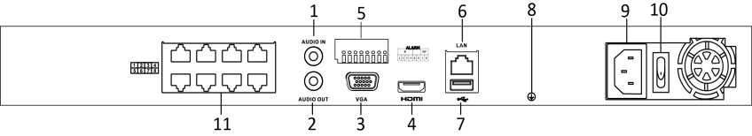
The picture shows the rear panel of NR32P8-8.
The NR32P4-4 and NR32P6-16 provide4 and 16 network Interfaces with PoE function. Please refer to the specification for the details.

NR32P4-4, NR32P8-8, NR32P6-16.
Available Models

