Operating Instructions

MAINTENANCE
Clean this unit with a soft, dry cloth. Never use alcohol, paint thinner of benzene to clean this unit.

PRODUCT SERVICE
- Damage requiring service: The unit should be serviced by qualified service personnel if:
- The DC power supply cord or AC adaptor has been damaged;
- Objects or liquids have gotten into the unit;
- The unit has been exposed to rain;
- The unit does not operate normally or exhibits a marked change in performance;
- The unit has been dropped or the cabinet damaged.
- Servicing Personnel: Do not attempt to service the unit beyond that described in these operating instructions. Refer all other servicing to authorized servicing personnel.
- Replacement parts: When parts need replacing ensure the servicer uses parts specified by the manufacturer or parts that have the same characteristics as the original parts. Unauthorized substitutes may result in fire, electric shock, or other hazards.
4) Safety check: After repairs or service, ask the servicer to perform safety checks to confirm that the unit is in proper working condition.

4
Operating Instructions
HDMI Converter
MODEL: SDH-T01
Operating Instructions
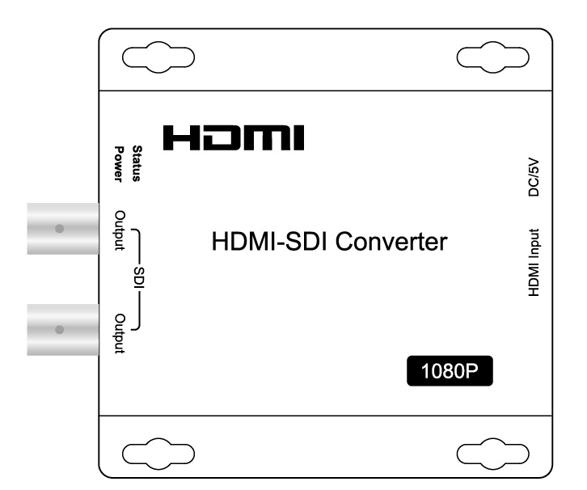

Dear Customer
Thank you for purchasing this product. For optimum performance and safety, please read these instructions carefully before connecting, operating or adjusting this product. Please keep this manual for future reference.

FEATURES
- HDMI to SDI Analog Conversion
- Full HDMI support including embedded audio
- Distributes 1 HDMI source to 2 SDI output simultaneously.
- Support 1080p@25Hz,1080p@29.97Hz,1080p@30Hz,1080P@60Hz
- Compliant HDCP
- Uses 5V power

NOTICE
Our company reserves the right to make changes in the hardware, packaging and any accompanying documentation without prior written notice.

1
Operating Instructions

TABLE OF CONTENTS
Specifications
Package Contents
Panel Descriptions
Connecting and Operating
Maintenance
Product service
Warranty

SPECIFICATIONS
Operating Temperature Range |  |  | -5 to +35℃(+23 to +95℉)
Operating Humidity Range |  |  | 5 to 90%RH (No Condensation)
Video Formats | HDMI |  | 480i / 576i / 720p (60 / 59.94 / 50) / 1080i (30 / 29.97 / 30) / 1080p (60 / 59.94 / 50 / 30 / 29.97 / 25 / 24 / 23.98)
Video Formats | SDI | SMPTE-425M | 1080p (60 / 59.94 / 50)
Video Formats | SDI | SMPTE-274M | 1080p (30 / 29.97 / 25 / 24 / 23.98)
Video Formats | SDI | SMPTE-274M | 1080i (60 / 59.94 / 50)
Video Formats | SDI | SMPTE-296M | 720p (60 / 59.94 / 50)
Video Formats | SDI | ITU-R BT.656 | 576i (50)
Video Formats | SDI | SMPTE-125M | 480i (59.94)
Input |  |  | HDMI
Outputs |  |  | 3G-SDI/HD-SDI/SDI
HDMI |  |  | Standard Type A connector  Video:  8-bit RGB 4:4:4 or  10-bit YCbCr 4:2:2 (selectable by internal jumper)  Audio:  24-bit, with 2 or 8 embedded channels (selectable by  internal jumper)
HDCP |  |  | Compliant HDCP
Power consumption |  |  | 2.5watts(Maximum)
Dimension (L×W×H) |  |  | 95x95x29mm
Net Weight |  |  | 245g
Note: Specifications are subject to change without notice. Mass and dimensions are approximate.

PACKING CONTENTS
- Main Unit. HDMI -SDI converter
- DC5V 1A Power Supply.
- Operating Instructions

2
Operating Instructions

PANEL DESCRIPTIONS
Output Panel Input Panel

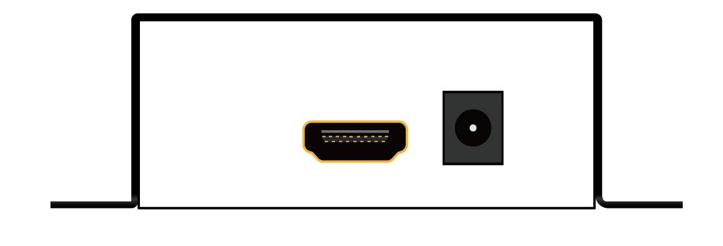
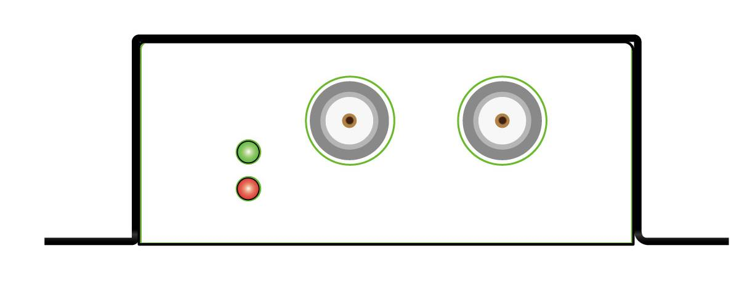






- Indicator of SDI Output
- Indicator of power Input
- SDI/HD-SDI Output port
- HDMI input port
- Power input

Connecting and Operating
- Ensure the Converter is disconnected from power.
- Connect source to the HDMI input and sink to SDI output.
- Connect 5VDC power to the converter.
Attention: Insert/Extract cable gently

Typical Application

